Calculus 2 Lecture 7.2: Techniques For Trigonometric Integrals
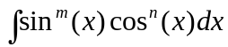
Two cases
- “m” and/or “n” is odd
- “m” and “n” are even

Case 1
If the power of sin is odd, then keep one factor of sin
And use pythagorean identity to change 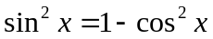

If the power of cos is odd, then keep one factor of cos
And use pythagorean identity to change 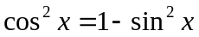

If both odd, then pick one that will give a power of 2 if possible

Case 2
If both even, then use half angle formulas
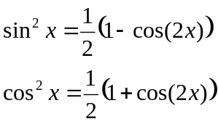
Example:
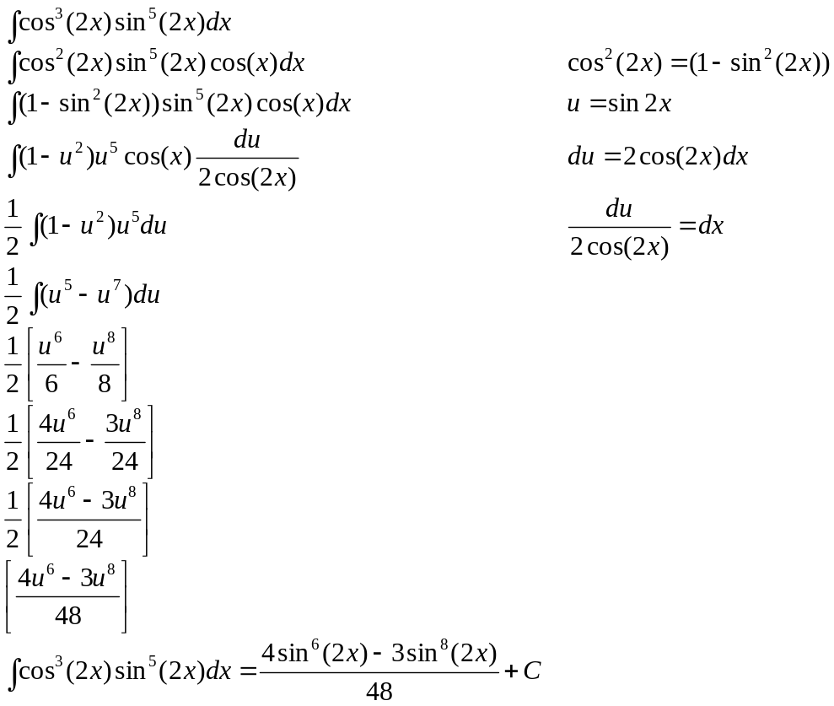

Example:
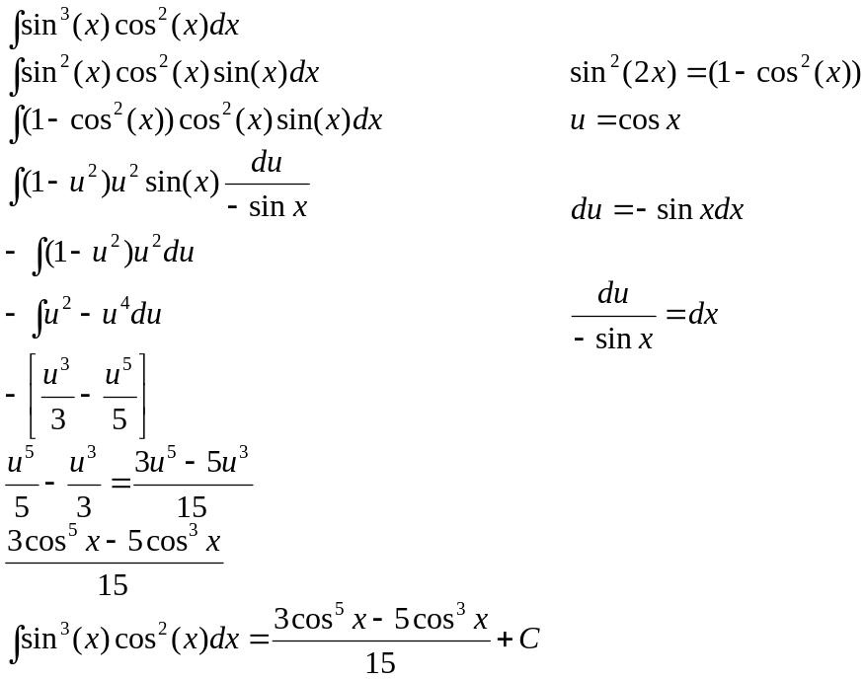

Example:
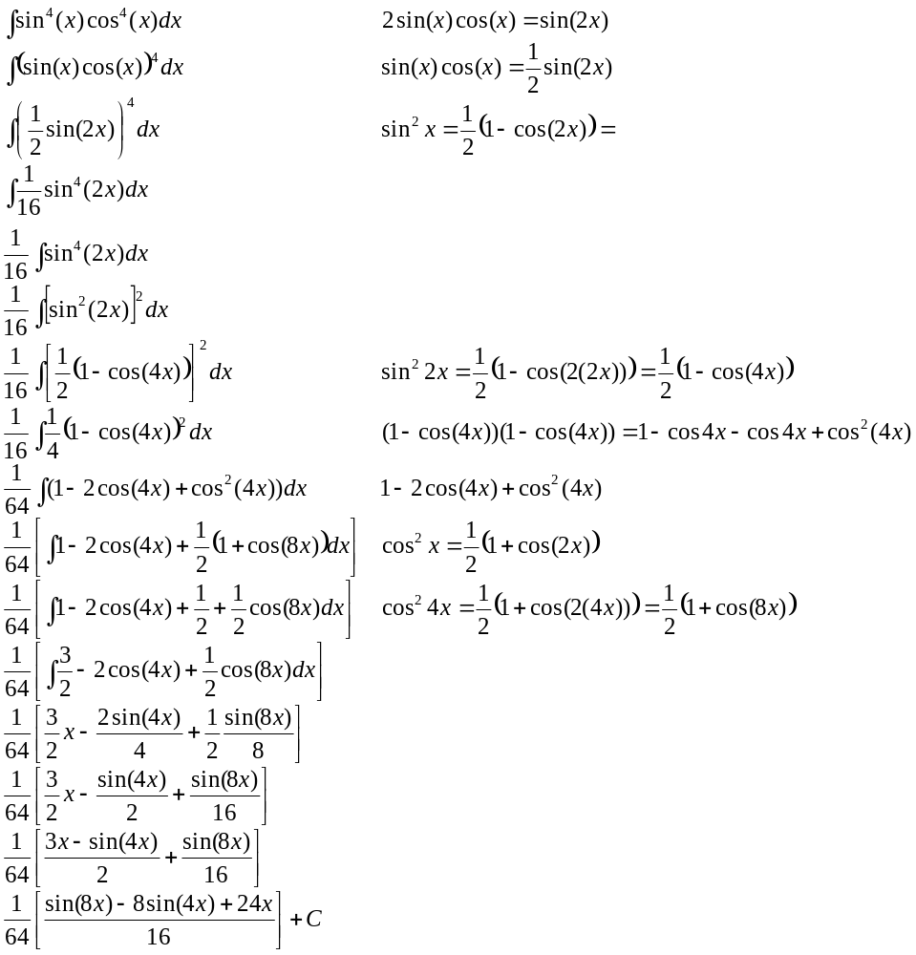
Reduction Formula
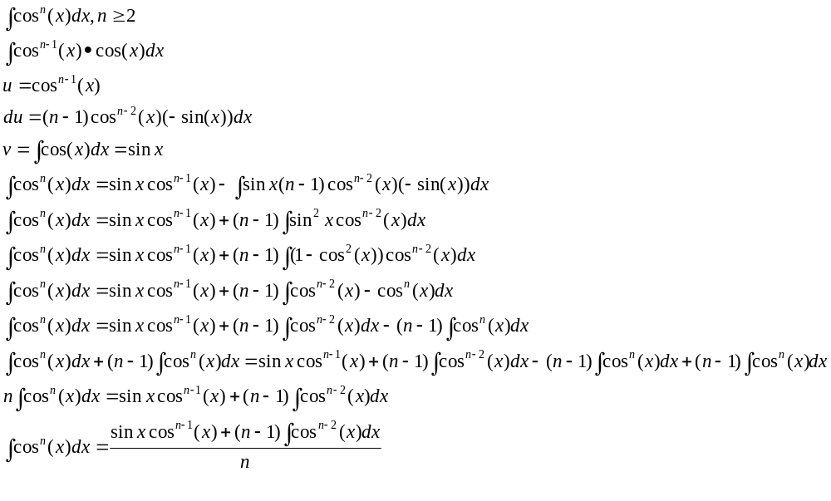
Example:
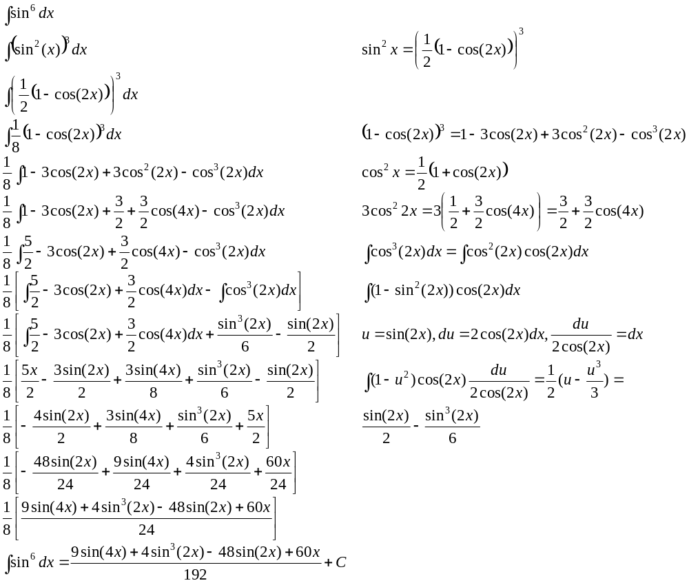

Example:
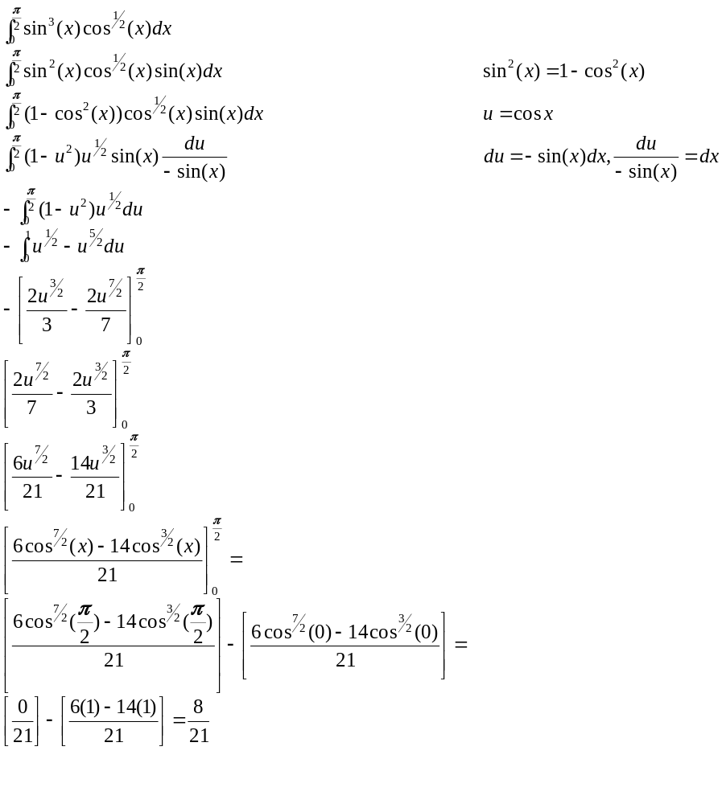
Example:

If the power of TAN is odd, keep 1 factor of 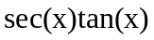
and use 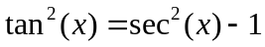

If the power of SEC is even, Strip off a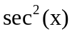
and use 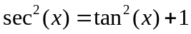

If the power of COT is odd, keep 1 factor of 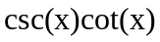
and use 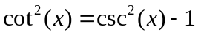

If the power of CSC is even, Strip off a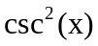
and use 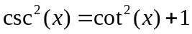

Example:
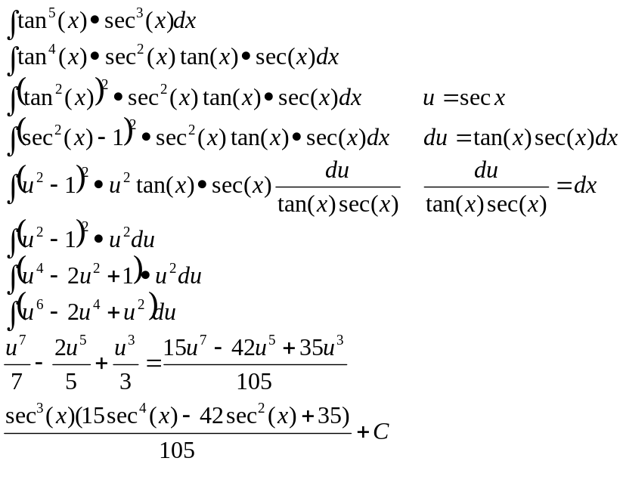

:

Example:
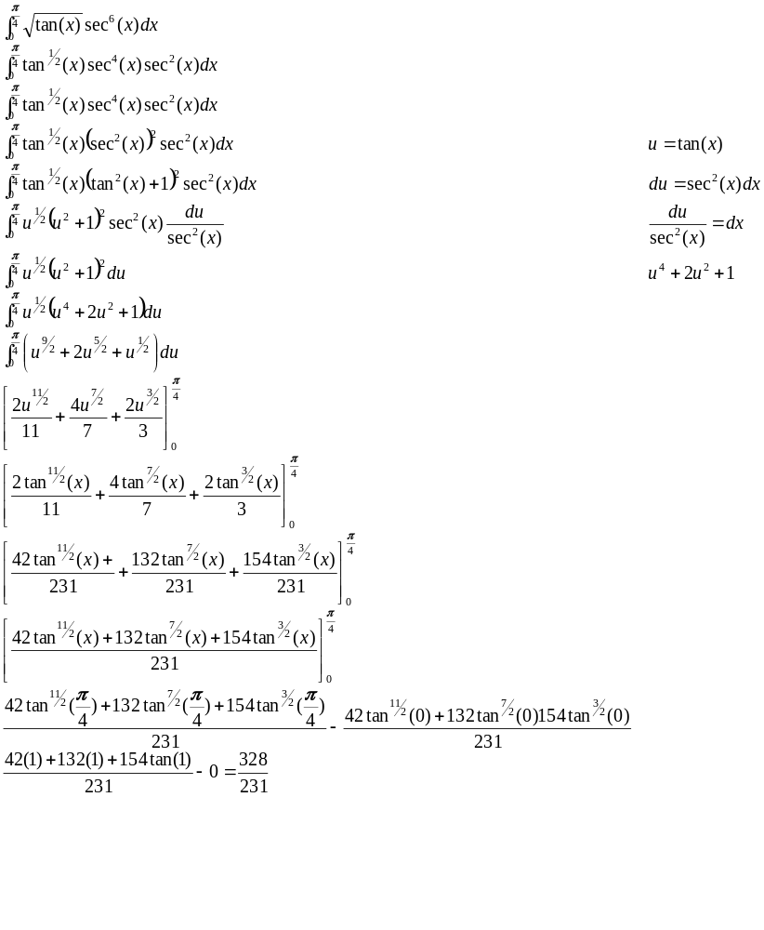
Example:
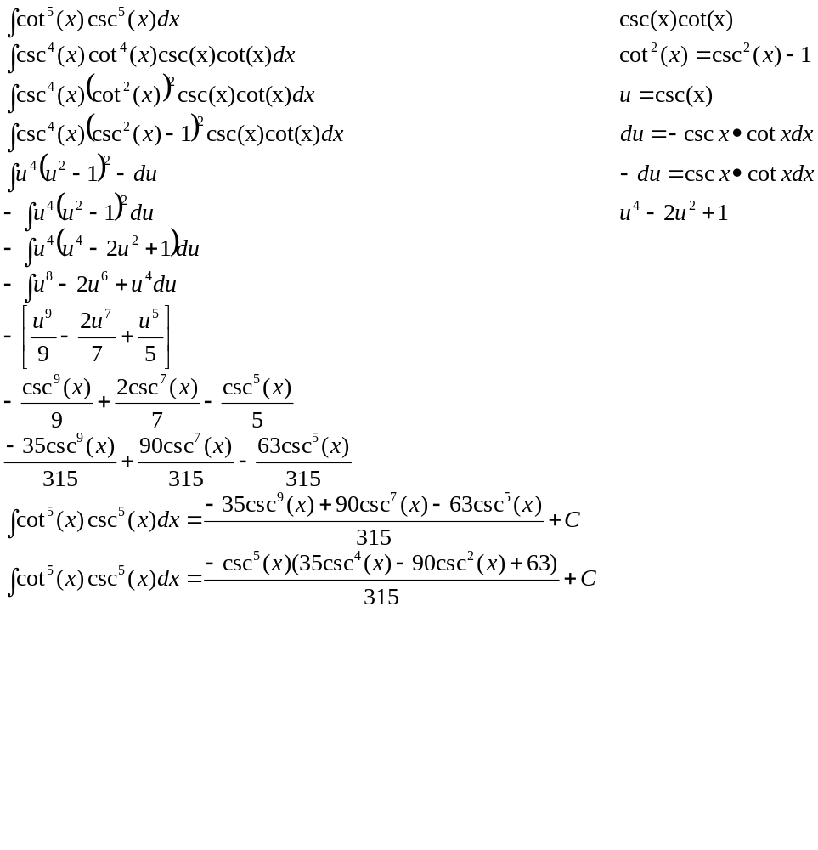
Example:
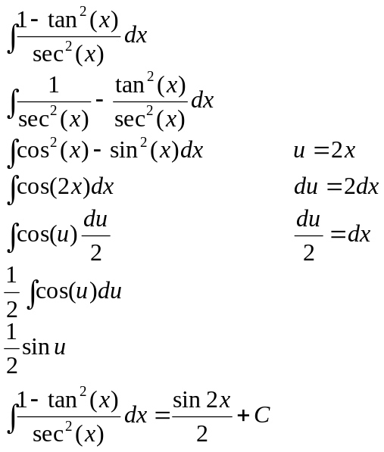

NOTE:
For integrals where sine and cosine with different angles.
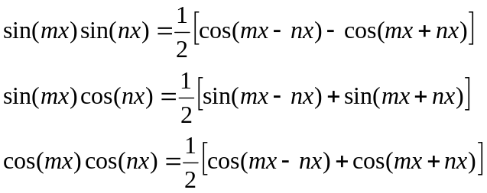

Example:
